**Inven BS**

Aplikasi inventaris barang sekolah menggunakan Framework Laravel 7.

**Prasyarat**

Berikut beberapa hal yang perlu diinstal terlebih dahulu:

* Composer (<https://getcomposer.org/>)
* PHP 7.2.x
* MySQL 14.5.x
* XAMPP

Jika Anda menggunakan XAMPP, untuk PHP dan MySQL sudah menjadi 1 (bundle) didalam aplikasi XAMPP

**Fitur**

* CRUD Barang
* Import/export excel barang
* Print
* CRUD BOS (Bantuan Operasional Sekolah)
* CRUD Ruangan

**Preview Gambar**

*Tampilan Login* [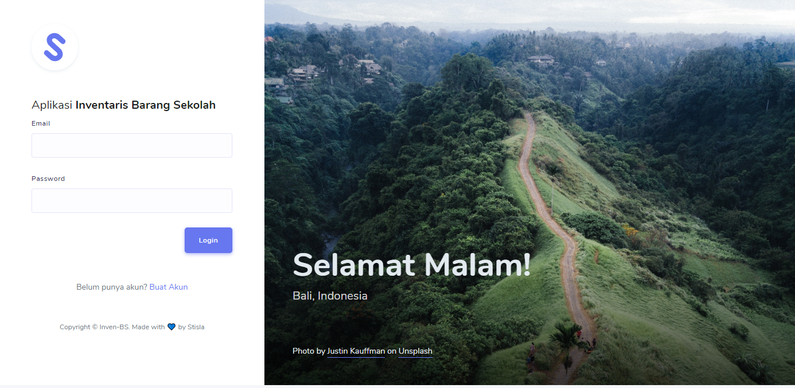](https://camo.githubusercontent.com/a7c32a5c6ce00359a83db93615a9185410c836148c580c77d82bf867dc238506/68747470733a2f2f692e696d6775722e636f6d2f5273695270314f2e706e67)

*Dashboard* [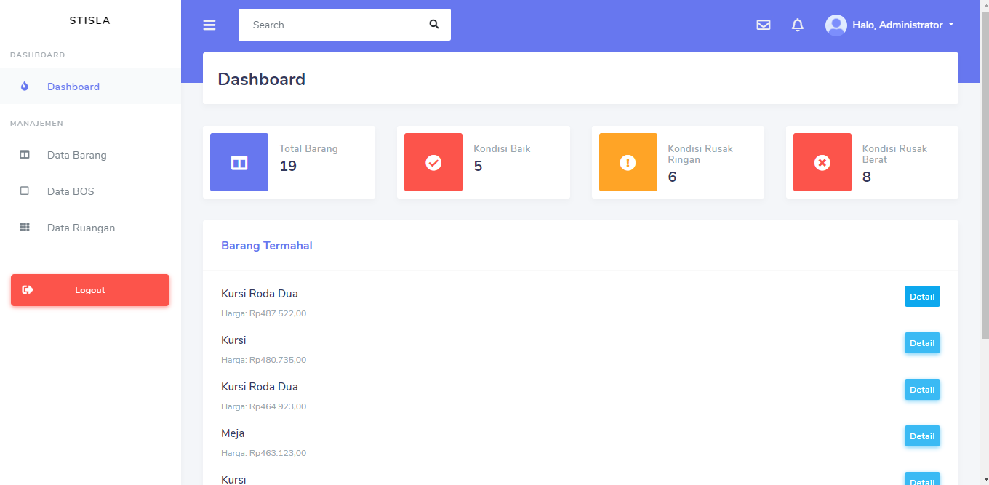](https://camo.githubusercontent.com/2b2bd40419a7f7b43ff271e1b838c7bdbd6823ddaa9cfc05881a7bb6d6515413/68747470733a2f2f692e696d6775722e636f6d2f77387450594f712e706e67)

*Daftar Barang* [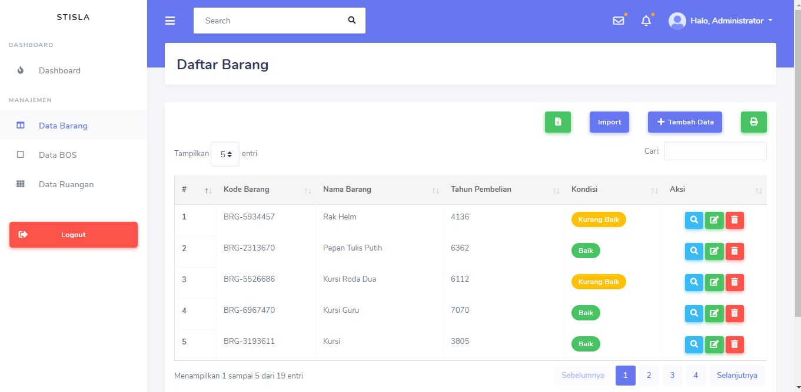](https://camo.githubusercontent.com/f95437ef0c714860404353e3709cbb35089b792b420b868fe2456d62e5c406c8/68747470733a2f2f692e696d6775722e636f6d2f4f6e3257396a4d2e706e67)

*Daftar Bantuan Operasional Sekolah* [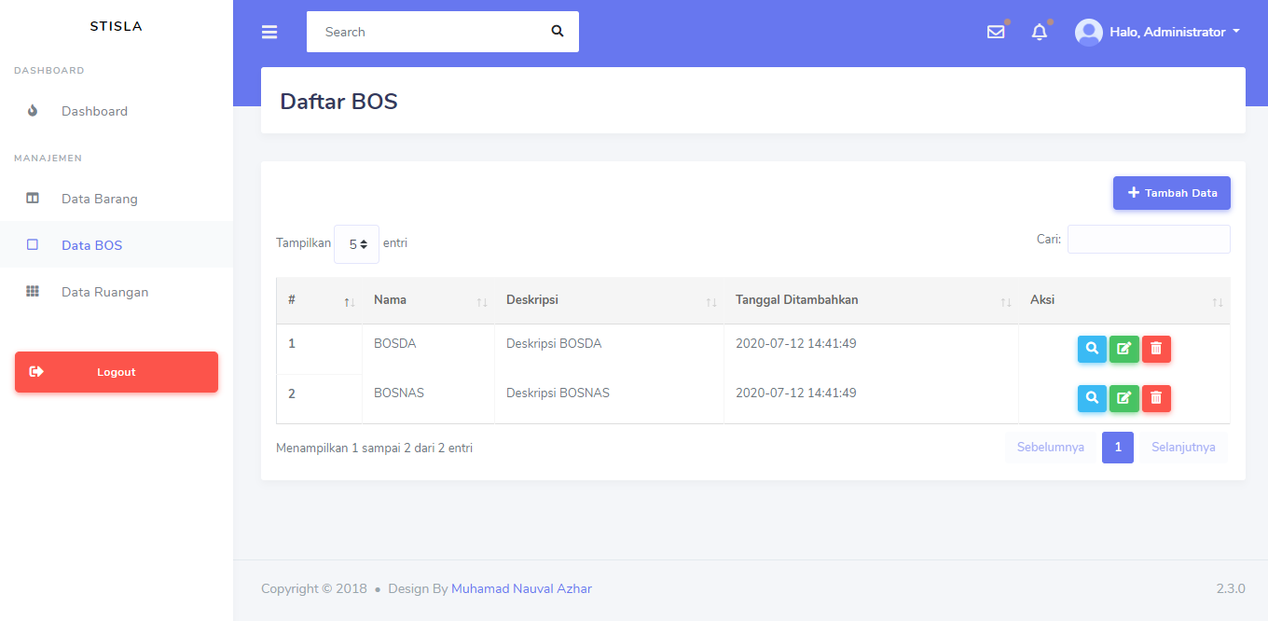](https://camo.githubusercontent.com/6a0a1bcb0f1dfd5bce315c8316447f910d62c166617249cebf1e4d8050232c20/68747470733a2f2f692e696d6775722e636f6d2f6d45594a63326a2e706e67)

*Daftar Ruangan* [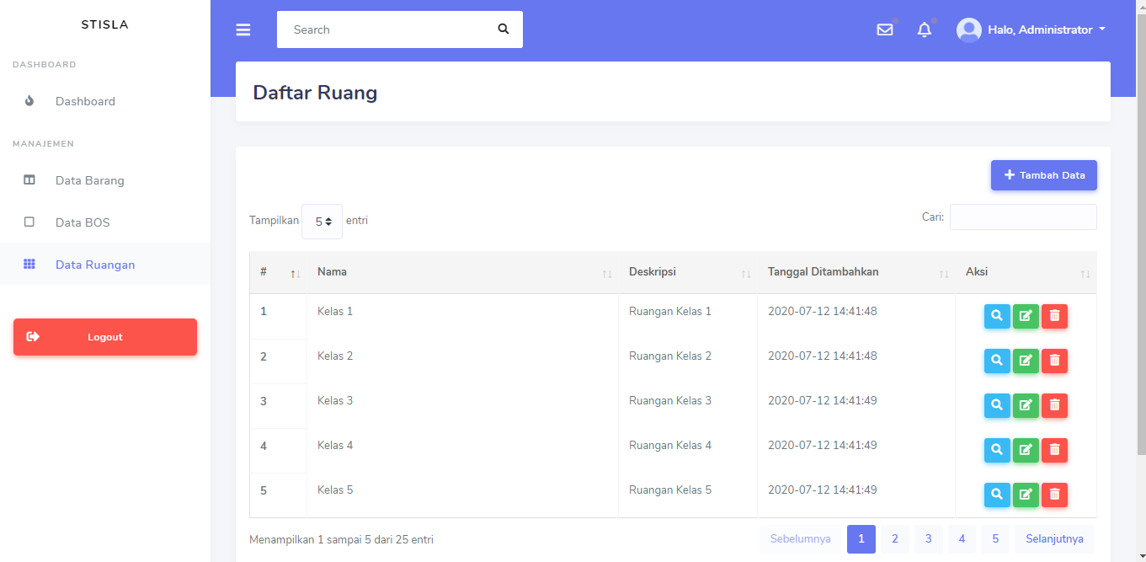](https://camo.githubusercontent.com/7471807f8affb52013bed97cd6ea83a8646b5f9c297040e28e0ac3ac00412ce3/68747470733a2f2f692e696d6775722e636f6d2f64375335494d562e706e67)

**Langkah-langkah instalasi**

* + **composer install**
* Siapkan database: **laravel** dan atur file .env sesuai dengan konfigurasi Anda

DB_CONNECTION=mysql

DB_HOST=127.0.0.1

DB_PORT=3306

DB_DATABASE=laravel

DB_USERNAME=root

DB_PASSWORD=

* Jika sudah, migrate seluruh migrasi dan seeding data
* **php artisan key:generate**
* **php artisan migrate**
* Jalankan local server
* **php artisan serve**
* User default aplikasi untuk login

Email : admin@mail.com

Password : admin

**Dibuat dengan**

* [Laravel](https://laravel.com/) - Web Framework

------------------------------------------------------------

Localhost:8000

<http://127.0.0.1:8000>